Mod 6:

|  |  |  |  |  |  |  |  |
| --- | --- | --- | --- | --- | --- | --- | --- |
| Reset | Inc | Q2 | Q1 | Q0 | Q2+ | Q1+ | Q0+ |
| 0 | 0 | 0 | 0 | 0 | 0 | 0 | 0 |
| 0 | 0 | 0 | 0 | 1 | 0 | 0 | 1 |
| 0 | 0 | 0 | 1 | 0 | 0 | 1 | 0 |
| 0 | 0 | 0 | 1 | 1 | 0 | 1 | 1 |
| 0 | 0 | 1 | 0 | 0 | 1 | 0 | 0 |
| 0 | 0 | 1 | 0 | 1 | 1 | 0 | 1 |
| 0 | 1 | 0 | 0 | 0 | 0 | 0 | 1 |
| 0 | 1 | 0 | 0 | 1 | 0 | 1 | 0 |
| 0 | 1 | 0 | 1 | 0 | 0 | 1 | 1 |
| 0 | 1 | 0 | 1 | 1 | 1 | 0 | 0 |
| 0 | 1 | 1 | 0 | 0 | 1 | 0 | 1 |
| 0 | 1 | 1 | 0 | 1 | 0 | 0 | 0 |
| 1 | X | X | X | X | 0 | 0 | 0 |

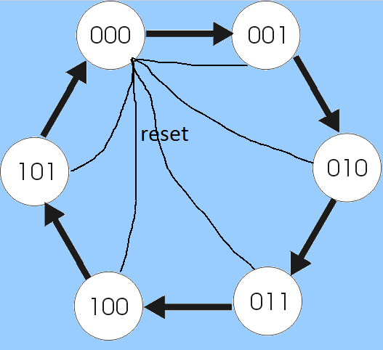

Q2+:

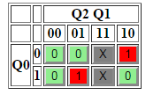

Q2+ = Q1 Q0 + Q2 Q0’

Q1+:

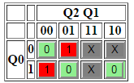

Q1+ = Q1 Q0’ + Q2’ Q1’ Q0

Q0+:

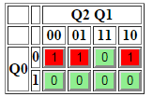

Q0+ = Q2’ Q0’ + Q1’ Q0’

Mod 10:

|  |  |  |  |  |  |  |  |
| --- | --- | --- | --- | --- | --- | --- | --- |
| Q3 | Q2 | Q1 | Q0 | Q3+ | Q2+ | Q1+ | Q0+ |
| 0 | 0 | 0 | 0 | 0 | 0 | 0 | 1 |
| 0 | 0 | 0 | 1 | 0 | 0 | 1 | 0 |
| 0 | 0 | 1 | 0 | 0 | 0 | 1 | 1 |
| 0 | 0 | 1 | 1 | 0 | 1 | 0 | 0 |
| 0 | 1 | 0 | 0 | 0 | 1 | 0 | 1 |
| 0 | 1 | 0 | 1 | 0 | 1 | 1 | 0 |
| 0 | 1 | 1 | 0 | 0 | 1 | 1 | 1 |
| 0 | 1 | 1 | 1 | 1 | 0 | 0 | 0 |
| 1 | 0 | 0 | 0 | 1 | 0 | 0 | 1 |
| 1 | 0 | 0 | 1 | 0 | 0 | 0 | 0 |

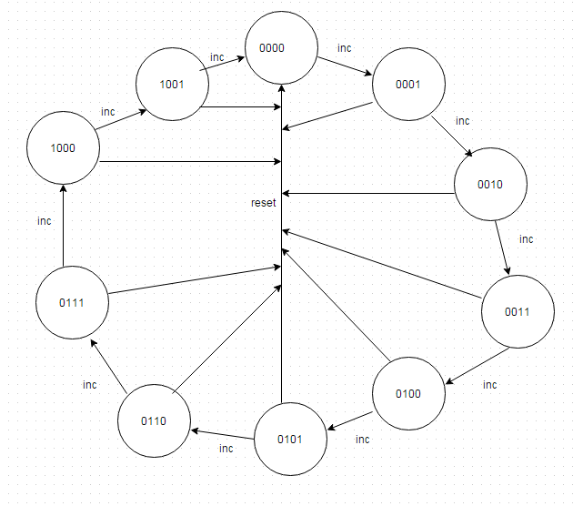

Q3+:

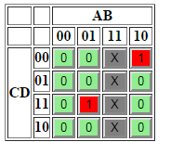

Q3+= Q2Q1Q0 + Q3Q1’Q0’

Q2+:

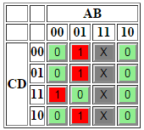

Q2+ = Q2Q1’ + Q2Q0’ + Q3’Q2’Q1Q0

Q1+:

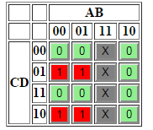

Q1+ = Q3’Q1’Q0 + Q3’Q1Q0’

Q0+:

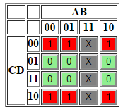

Q0+ = Q0’

SR Latch:

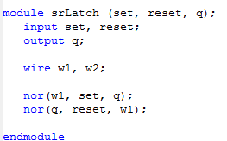



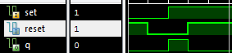

Mod 6:

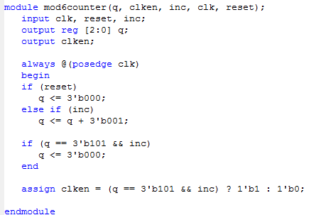



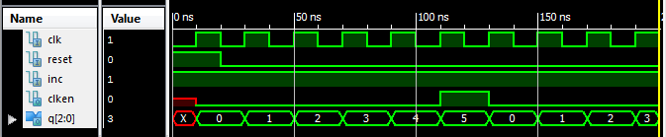

Mod 10:

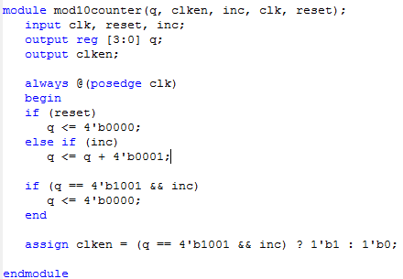



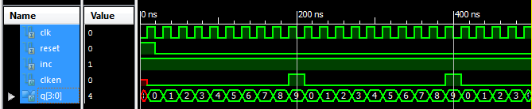

Block Counter:

